EXPERIMENT 5
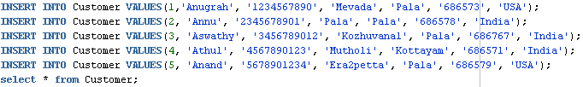
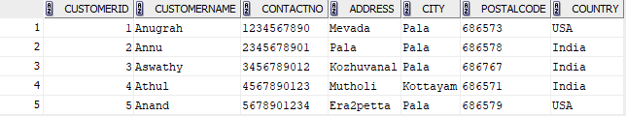

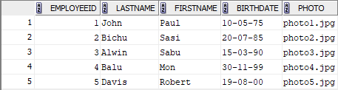

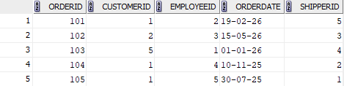

1. SELECT * FROM Customer ORDER BY CustomerName ASC;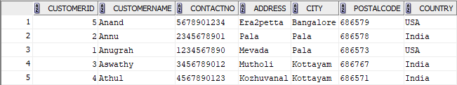

2. SELECT * FROM Orders ORDER BY OrderDate ASC;
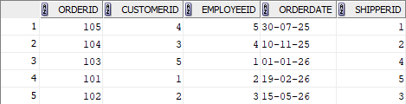

3. SELECT * FROM Employees WHERE BirthDate > '01-01-1980' ORDER BY BirthDate DESC;
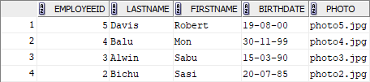

4. SELECT * FROM Orders WHERE CustomerID IN (SELECT CustomerID FROM Customer WHERE Country = 'USA') ORDER BY OrderDate DESC;
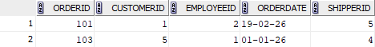
5. SELECT CustomerID, COUNT(OrderID) AS TotalOrders FROM Orders GROUP BY CustomerID;
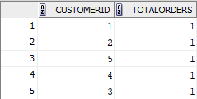
6. SELECT City, COUNT(CustomerID) AS TotalCustomers FROM Customer GROUP BY City;
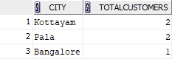
7. SELECT CustomerID, COUNT(OrderID) AS TotalOrders FROM Orders GROUP BY CustomerID HAVING COUNT(OrderID) > 2;
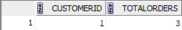
8. SELECT City, COUNT(CustomerID) AS TotalCustomers FROM Customer GROUP BY City HAVING COUNT(CustomerID) > 3;
